**Exam O300 Course Planner’s Module**

**(updated: 2025-01-25 Ian Sidders)**

**HPS / 50**

1. List 5 things that are part of a course planner’s responsibility? (5 Marks)
2. The course planner must keep what five (5) principles in mind when designing courses? (5 Marks)
3. Where can details of the age classes and recommended winning times for Canada Cup courses be found? (3 Marks)
4. Explain 2 ways of dealing with a busy road crossing. (2 Marks)
5. Which of the below map controls is suitable for a TD1 Course. (1 Mark)

A

B

C

D

E

F

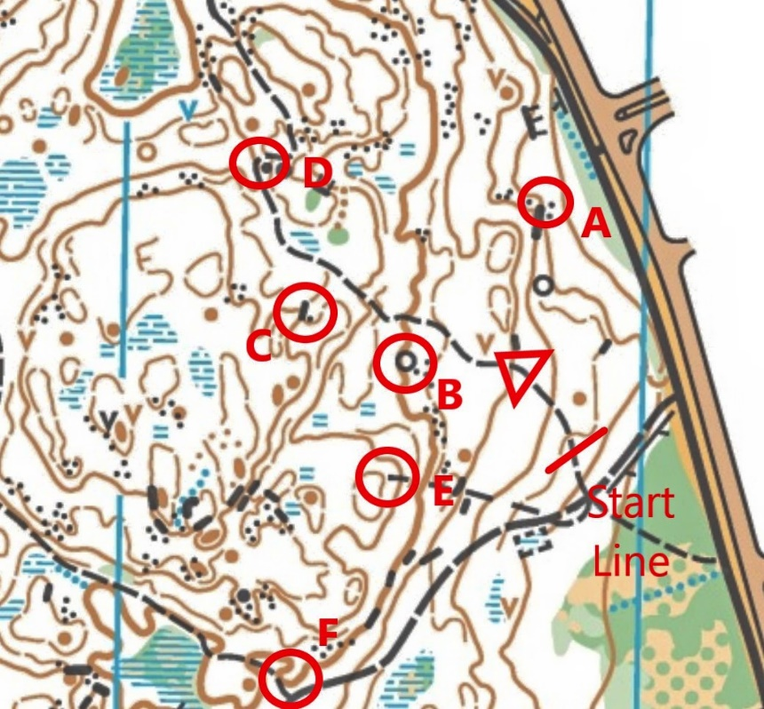

1. Briefly describe the set up for a good entry into the last control before the finish. (2 Marks)
2. What does ISSprOM stand for and how does it differ from ISOM? (2 Marks)
3. What must be available at a control in case a SI unit fails? (2 Marks)
4. List 3 characteristics of the profile of Sprint races. (3 Marks)
5. What map standard and scale are used for Sprint? (1 Mark)
6. List 3 characteristics of the profile for the Middle. (3 Marks)
7. What map standard and scale are used for the Middle? (1 Mark)
8. List 3 characteristics of the profile for the Long. (3 Marks)
9. Explain how you would determine the appropriate distance for the M55-64 class on the Long race. (3 Marks)
10. For course 1 on the Long, list 1 characteristic for each of terrain, map, leg, and control. (4 Marks)
11. Why is course 5 not part of the linear progression in length and technical difficulty of courses 1 through 11? (2 Marks)
12. Can a competitor run across a marsh in a Middle event race that is surrounded by a heavy black line? (2 Marks)
13. The landowner has a deer fence on his property marked with a double tag. How can the course planner ensure that no competitors will try to cross this area? (2 Marks)
14. What is the cardinal sin of course planning? (2 Marks)
15. Which course planning guideline is violated below? (2 Marks)

|  |  |  |  |  |
| --- | --- | --- | --- | --- |
| Age Group | Course | TD | Length | Climb |
| F10 | 1 | 1 | 3.2 | 90 |
| F11-12 | 2 | 2 | 3.1 | 120 |
| F13-14 | 3 | 3 | 3.5 | 120 |
| F15-16 | 4 | 3 | 4 | 145 |
| F17-18 | 8 | 5 | 4.7 | 130 |
| F19-20 | 9 | 5 | 6.8 | 230 |
| F21 Elite | 10 | 5 | 10.3 | 350 |
| F45 | 7 | 5 | 4.3 | 180 |
| F55 | 6 | 5 | 4 | 145 |
| F75 | 5 | 4 | 1.6 | 70 |