Orienteering Canada
O 200 Exam
2022-05-11
50 points
Note to markers. The answers given in this key are not necessarily the only correct answers. Unless the questions specifically request answers quoted directly from the manual the marker should use his/her discretion. The topic of the question is discussed, perhaps indirectly, in the section(s) cited in the answer key. The topic may also be referenced elsewhere in the manual.
Exam is open book. Answers may be written in sentences or point form. One point for each answer, e.g., if a question is worth two points, provide two different answers.
- You are planning a B event. The event is being held on a map that has not been updated recently. As course planner, name two ways you could ensure that your courses are fun, safe, and fair for all participants. (2 points)
- Name three ways a course planner can create route choice. (3 points)
- Describe three criteria for an acceptable beginner course control location. (3 points)
- Name three characteristics of a well-planned intermediate course. (3 points)

- Describe five things B event organizers should do to create a safe environment for participants. (5 points)
- According to the Manual, Orienteering Canada Rules state that there will be water on the course if the expected winning time is more than: (1 point)
- 30 minutes
- 45 minutes
- 1 hour
- There is no rule about placing water on the course
7. A handrail is a linear feature which assists a runner in navigating from one location to another. Different levels of orienteering skill are required to use various types of linear features as handrails. Name two linear features that can be used by beginner runners, two that can be used by intermediate level runners and two which typically require advanced orienteering skill. (3 points – 0.5 points per answer)

8. It costs money to put on an orienteering event. What are some of the expense items an event director may have to claim for? (2 points)

9. At a B event, a participant comes to the finish insisting that a control on the course is misplaced. Other participants concur. You are the event director. How do you handle the situation? (2 points)

10. There are, according to the manual, two principles that are central to the role of a controller. What are they? (2 points)

11. List four of the actions that a C event controller would take in fulfilling that role. (4 points)
12. In what way does a B event typically differ from a C event. In other words, what are some B event characteristics that a controller might monitor. (3 points)

13. List some of the topics to cover in a beginner clinic. (3 Points)

14. Describe the important factors to address in setting up a finish. (3 points)

15. True or False. According to the Manual, Canadian Orienteering rules require: (3 points – 0.5 points per correct answer)
T/F Participants may run anywhere on the map irrespective of markings.
T/F Participants are to help other participants if they are injured.
T/F The international distress signal is four blasts of a whistle.
T/F The safety bearing, for lost participants, must be printed on the map.
T/F Orienteering is about maps and participants may carry maps in addition to the map assigned by the organizers.
T/F Out of bounds areas must be marked with barrier tape.

16. True or False. A B event requires: (3 points – 0.5 points per correct answer)
T/F An event director
T/F A controller
T/F 8 courses
T/F A banquet
T/F Direction signage
T/F Water and other refreshments at the finish
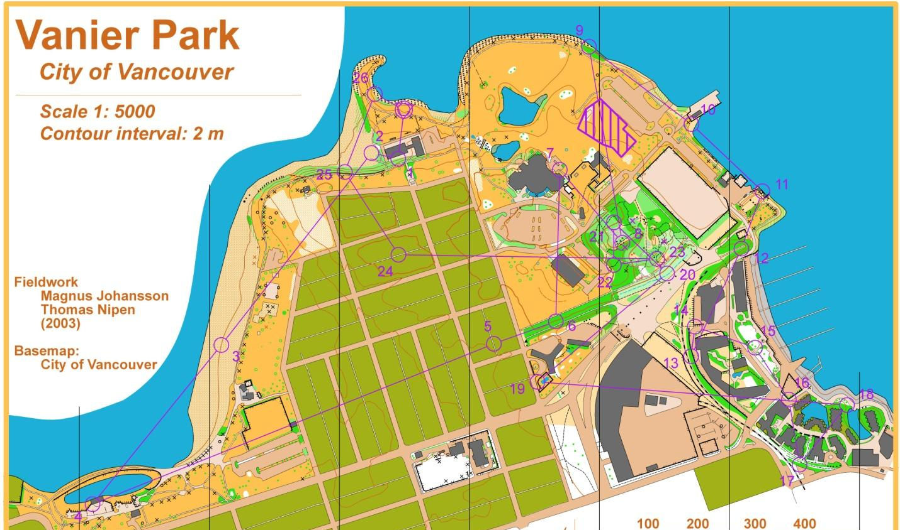
17. You are the controller for a C event. The first-time course planner submits the following course for review (see Vanier Park map). Provide at least six suggestions to the course planner to help them improve their course (5 points)

